

**Product Portfolio Management**



Home Page:

To Home Page, choose one of the following Icons.

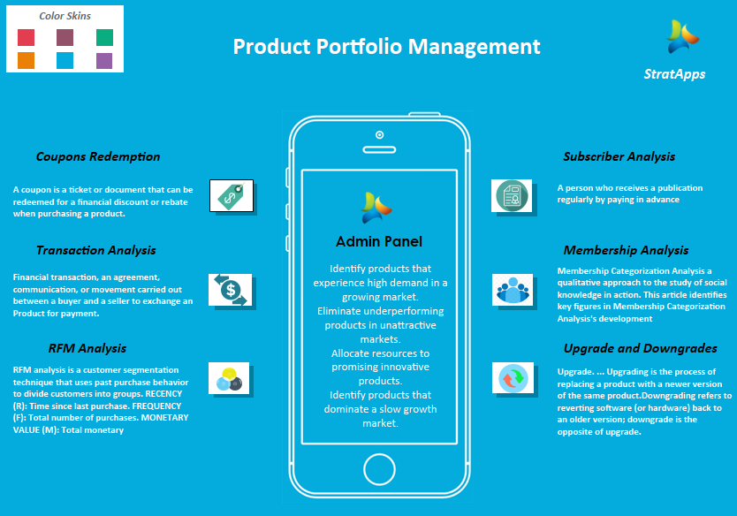

To identify products that experience high demand in a growing market. Eliminate underperforming products in unattractive markets. Allocate resources to promising innovative products. Identify products that dominate a slow growth market.

**Coupon Redemption:**  C**oupon** is a ticket or document that can be redeemed for a financial discount or rebate when purchasing a product.  
 Customarily, coupons are issued by manufacturers of consumer packaged goods or by retailers, to be used in retail stores as a part of sales promotions. You can restrict coupon redemptions by customer, time, or order configurable redemption limits (such as redemption limit per coupon code, redemption limit per customer or redemption limit per time frame). If the customer provides a coupon code that has not reached its redemption limits, the customer qualifies for any promotion associated with that coupon. Since only price conscious consumers are likely to spend the time to claim the savings, coupons function as a form of price discrimination, enabling retailers to offer a lower price only to those consumers who would otherwise go elsewhere. In addition, coupons can also be targeted selectively to regional markets in which price competition is great.

Coupon Redemption view explains details of coupons and there success failure rating , if you want to see the further details of that particular coupon used customer details then click on the filled bars.



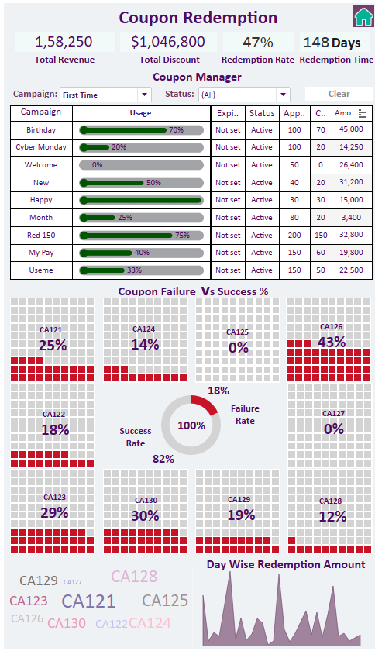



You can restrict coupon redemptions by customer, time, or order configurable redemption limits (such as redemption limit per coupon code, redemption limit per customer or redemption limit per time frame). If the customer provides a coupon code that has not reached its redemption limits, the customer qualifies for any promotion associated with that coupon.

This Detailed Report Explain the details of that Particular Coupon used customers with the Redeemed value.

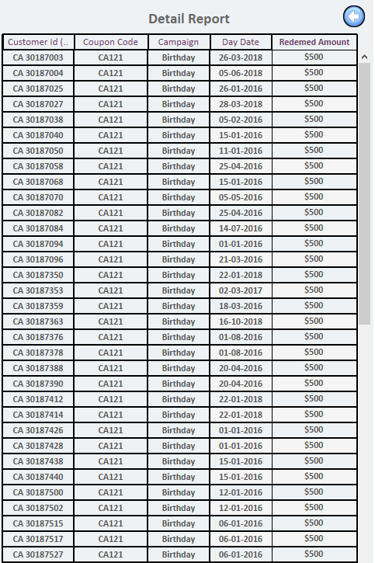



The **Subscribers Report** calculates the total number of active accounts and subscribers over a selected time period. The **Subscriber Growth Report** calculates the number of new subscribers, returning subscribers and churned subscribers and the Net positive or negative change over a selected time period.

The **Subscriber Retention Report** is a cohort analysis looking at retention (and churn) over time for each group of paying subscribers that signed up in a given month.

The **Churn Analysis Report** calculates the total number of subscriptions that have expired during a selected time period, sectioned by expiration reason. Each expiration reason is categorized into one of two types of churn: Voluntary or Involuntary.

If you want to drill down the further details then click on the Reports.

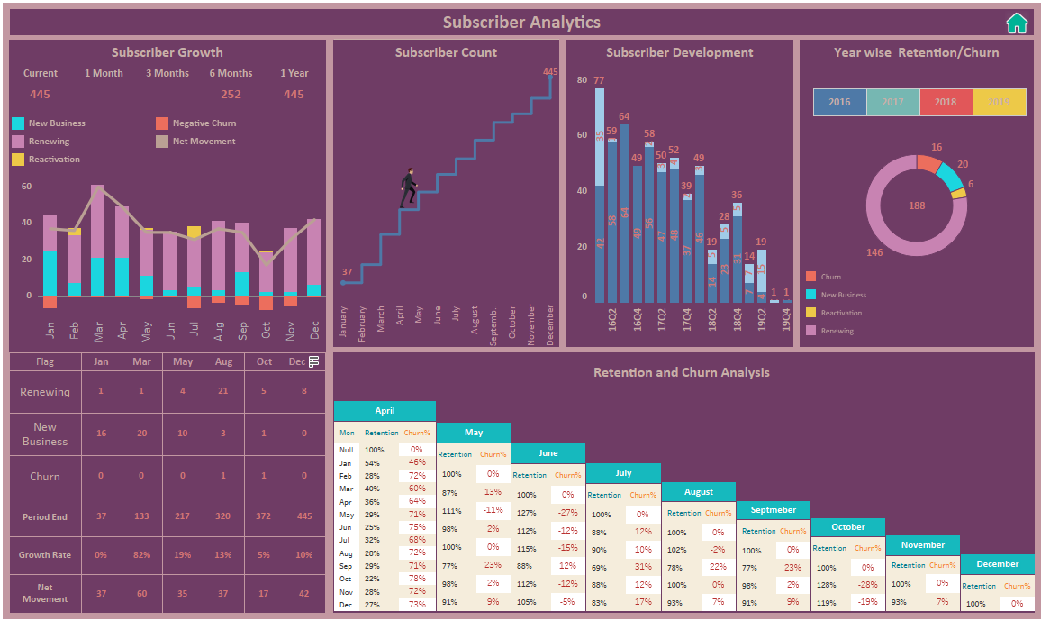



In this detailed report explain all the Subscriber details.

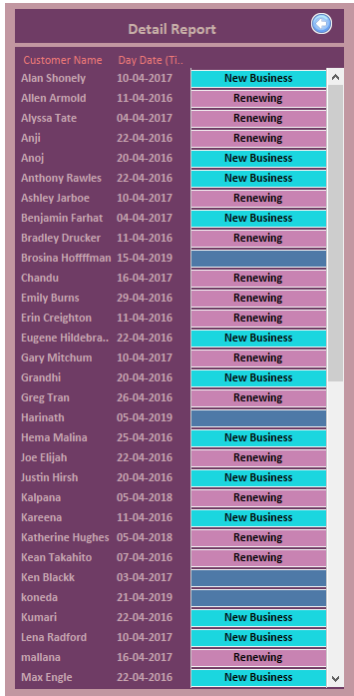



Transaction Analysis: Financial Transaction an agreement communication or movement carried out between a buyer and a seller to exchange product for payment.

In this Transaction Report is showing in a calendar view year wise click on year.

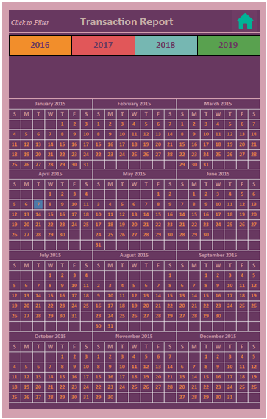



Click on year wise it drilldown to month wise it shows the every month in that year.

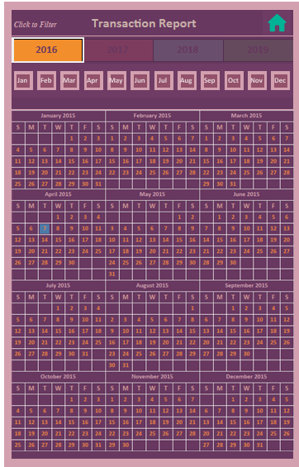

Here we click on any month in that year it drilldown to day wise report in a calendar view, in this calendar view it shows the each day Paid or Hold or Decline Transactions in different colors. If we click on any day it will move to detailed transaction report.

RFM Analysis is a Customer Segmentation Technique that uses past purchase behavior to divide customers into Segments. RECENCY (R): Time since last Purchase, FREQUENCY (F): Total number of purchases, MONETARY VALUE (M): Total monetary value RFM analysis is a marketing technique used to determine quantitatively which customers are the best ones by examining how recently a customer has purchased (recency), how often they purchase (frequency), and how much the customer spends (monetary). RFM analysis is based on the marketing axiom that "80% of your business comes from 20% of your Customers”. It will show the Segment wise how many customers because we catch the lost cheap customers easily, we can hold that customers he can travel with us so that company revenue will be generated.



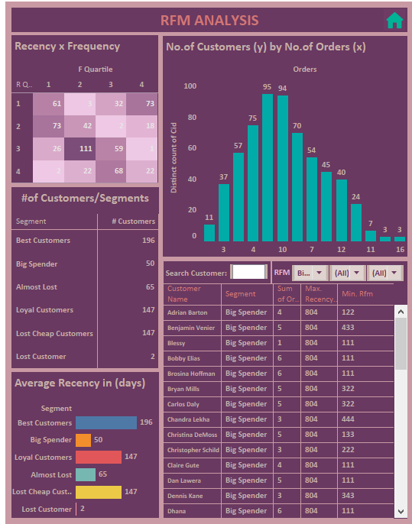



In this Detailed Report shows all the Order wise details of the members and Income of the member, we have further drilldown here we can click on the order in tooltip we have an option Order View details.

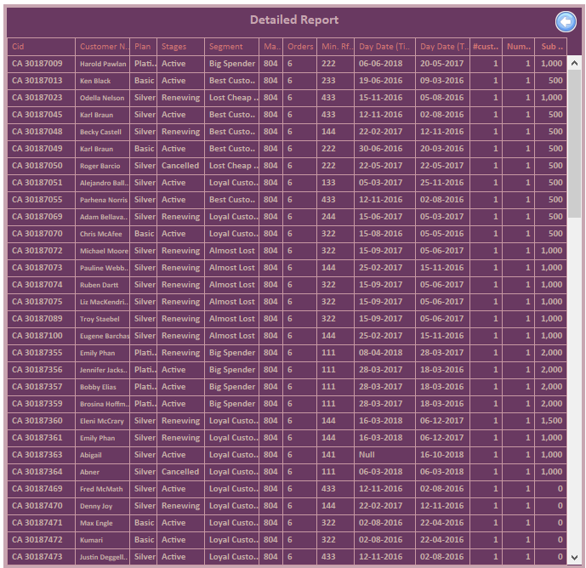



In this Report shows all the Order details of the member.

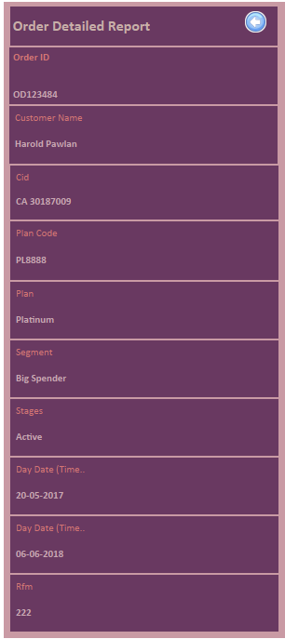



Membership Analysis is showing Year wise, Quarter wise, Month wise and Day wise how many subscriptions subscribe the plans (Basic, Silver, Gold, Platinum). Membership Distribution analysis describe the plan wise how many members and Income of that members and it shows the Current members ,Cancelled members, Expiring members, some are Complimentary ,Renewing members, Trail members and Income of that particular month. The Life time of that Customer show the how many members subscribe the plan wise.

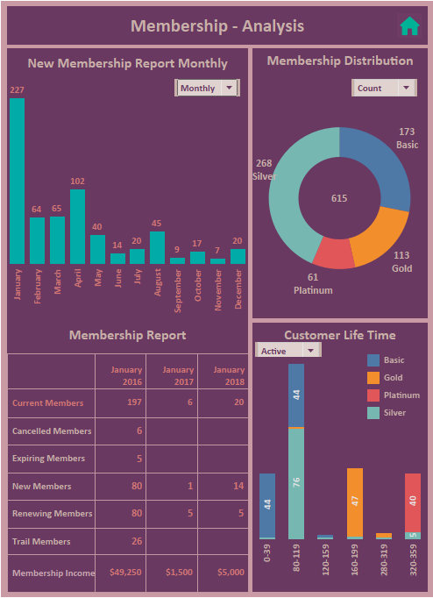



This Detailed Report Shows all the details of a Membership Analysis

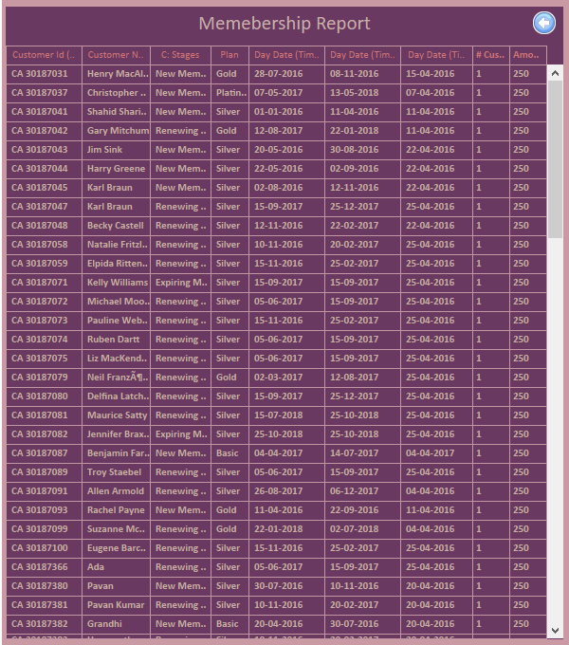



Upgrades and Downgrades Report show the Last Four Years of overall income of that particular plan like(Basic, Silver, Gold, Platinum).

We have a filter option show the month wise income of that particular year.

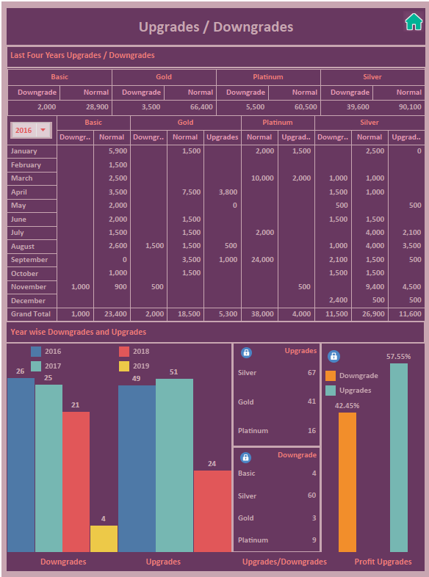



In this Detailed report shows all the details of the Upgrades and Downgrades of the customers.

